Name: Date:

Computer Networks – Knowledge Check #9

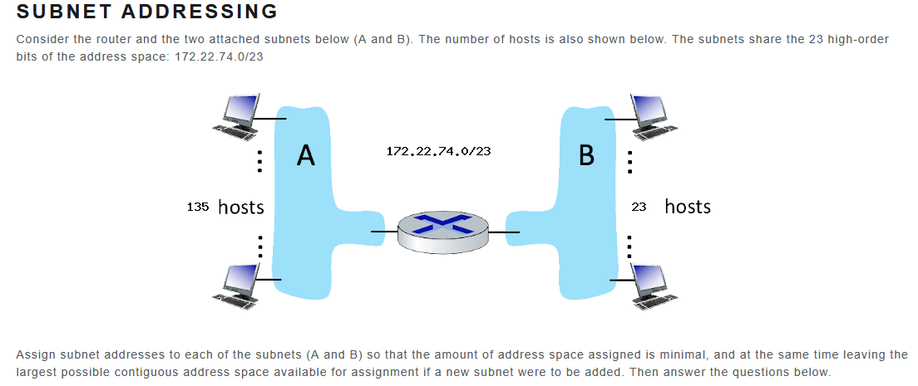

What is the subnet address of subnet A? (CIDR notation)
What is the broadcast address of subnet A?
What is the starting host address of subnet A?
What is the ending host address of subnet A?

What is the subnet address of subnet B? (CIDR notation)
What is the broadcast address of subnet B?
What is the starting host address of subnet B?
What is the ending host address of subnet B?

